**Computer Hardware**

**Class Five**

**Lab 2**

|  |
| --- |
| Lab Objectives:  * Memory * Storage |

# ROM:

## IMG_256Short for read-only memory, ROM is a [storage medium](https://www.computerhope.com/jargon/s/stordevi.htm) that is used with computers and other electronic devices.

## As the name indicates, data stored in ROM may only be [read](https://www.computerhope.com/jargon/r/read.htm). It is either modified with extreme difficulty or not at all.

# RAM:

## Alternatively referred to as main memory, primary memory, or system memory.

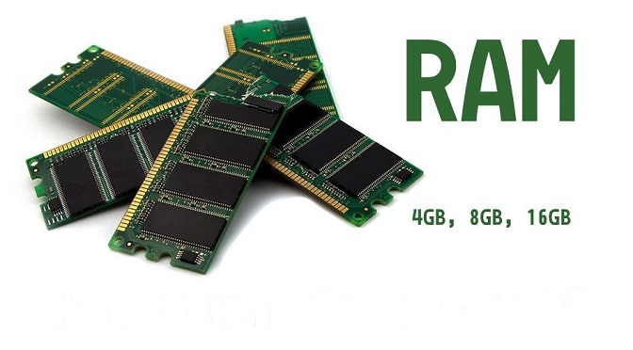

## RAM (random access memory) is a hardware device that allows information to be stored and retrieved on a computer.

# Difference Between ROM and RAM?

There is one major difference between a ROM (read-only memory) and a RAM (random-access memory) chip.

ROM can hold data without power and RAM cannot.

Essentially, ROM is meant for permanent storage, and RAM is for temporary storage.

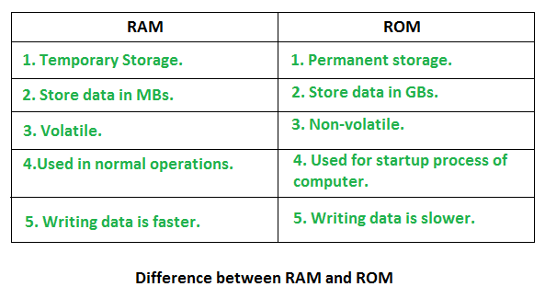

## N.B: Volatile is computer memory that requires power to maintain the stored information

# Hard Disc

## A hard disk drive, hard disk, hard drive, or fixed disk, is an electro-mechanical data storage device that uses magnetic storage to store and retrieve digital information

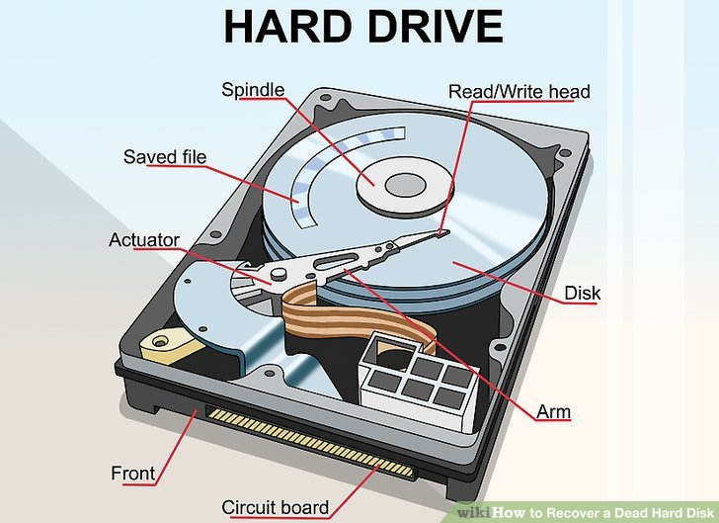

# CD (**compact disc)**

A compact disc is a portable storage medium that can be used to record, store and play back audio, video and other data in [digital](https://whatis.techtarget.com/definition/digital) form.

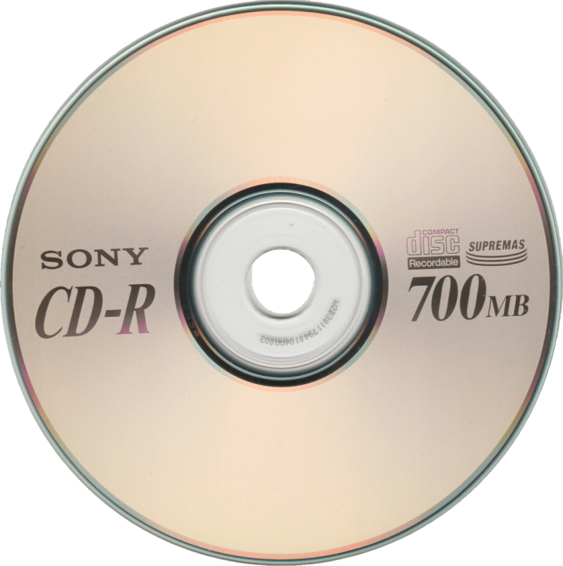

# DVD (digital video disk)

## IMG_256DVD is an optical disc technology with a 4.7 gigabyte storage capacity.

# Flash Drive

## a small electronic device containing flash memory that is used for storing data or transferring it to or from a computer, digital camera, etc.

## A USB flash drive, also known as a thumb drive, pen drive, gig stick, flash stick, jump drive, disk key, disk on key, flash-drive, memory stick, USB key, USB stick or USB memory.

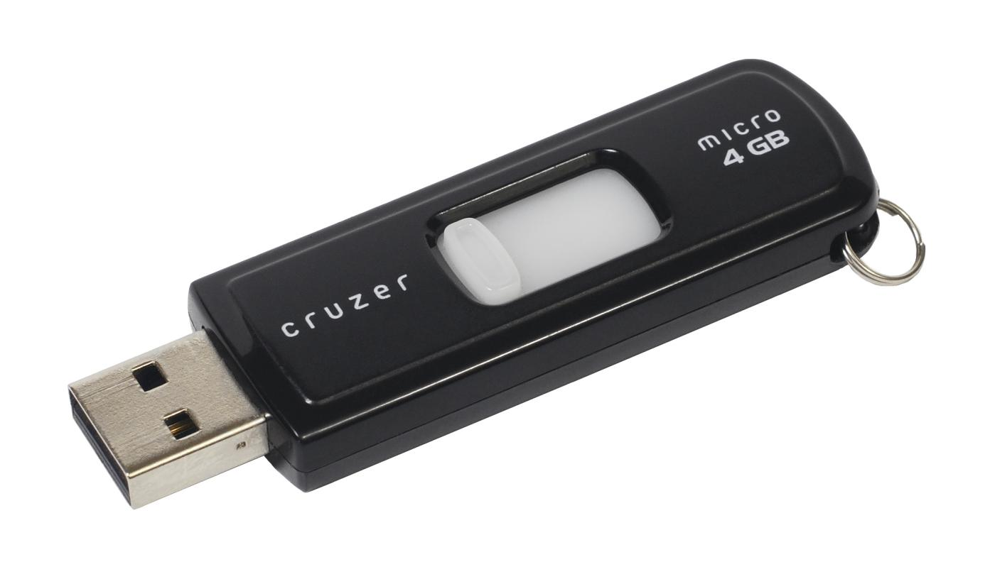

# Memory Card

## IMG_256A memory card, flash card or memory cartridge is an electronic flash memory data storage device used for storing digital information.